1.program to print Fibonacci upto given number:

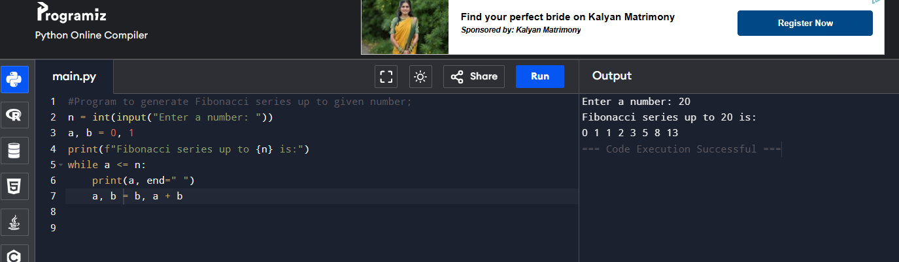

2.program to generate first n terms in Fibonacci series :

